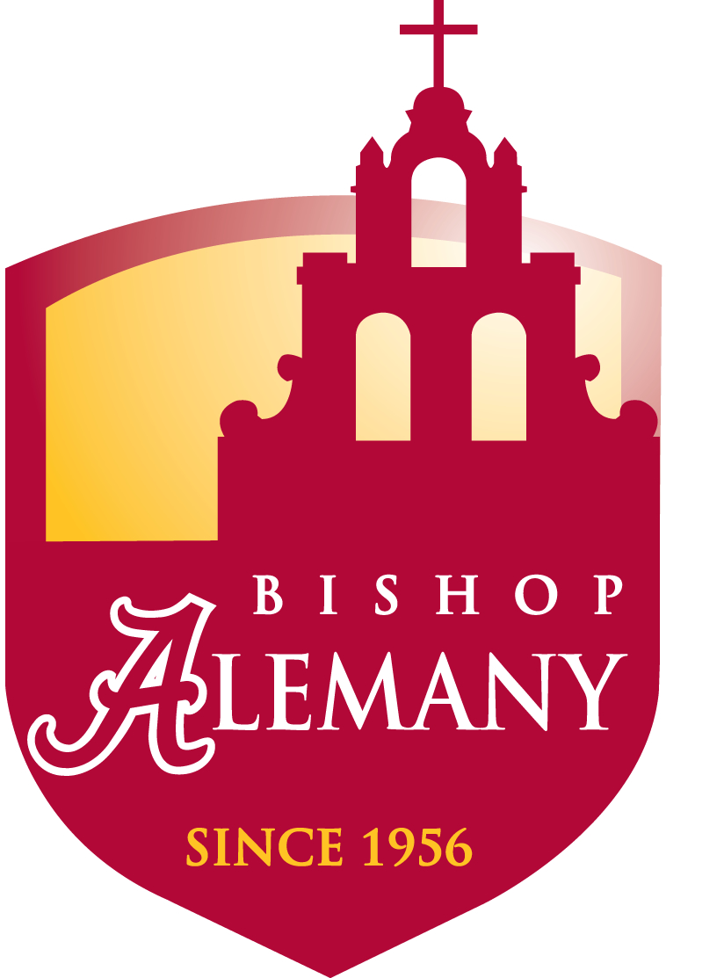

The Bishop Alemany Parent Association
is pleased to invite you to a
“New Parent Welcome Reception”
Wednesday, May 4th
At 7pm
In the Courtyard

It will be an evening to meet your fellow
New parents, The Parent Association
Board members and Faculty & Staff
while enjoying Cinco de Mayo refreshments!

We look forward to seeing you and welcoming
you into the Alemany Family!


